Assignment 6-3: Interpreting UML Diagrams
Blake Merry
Southern New Hampshire University
CS-255 System Analysis and Design
Prof. Denise Washington
October 15, 2026

Diagram Interpretation
Both UML diagrams represent the process of withdrawing cash from an ATM, but they illustrate different aspects of that process. The activity diagram focuses on the steps and decisions involved in completing a withdrawal, while the sequence diagram shows the interactions between the user, ATM, and bank. The user inserts their card and enters a PIN, which the ATM sends to the bank for verification. Once the bank confirms the PIN is valid, the ATM prompts the user to enter a withdrawal amount. The user enters the amount, and the ATM dispenses the cash. The activity diagram also accounts for situations where the PIN is incorrect or the requested amount is unavailable, showing how those conditions affect the transaction.

Design Analysis
One significant drawback I noticed is that the sequence diagram does not show checks to determine whether the account has sufficient funds or whether the ATM has enough cash available before dispensing money. Although the activity diagram includes a decision for an unavailable amount, it doesn't show how that availability is determined. This could be addressed by checking the customer's account balance with the bank and verifying the ATM's available cash before authorizing the withdrawal. Another issue is how the system handles an incorrect PIN. The activity diagram immediately ends the transaction without displaying an error or allowing the customer to try again, while the sequence diagram doesn't represent an incorrect PIN response at all. Providing clear feedback and a limited number of retry attempts would make the system more practical and user-friendly.
Figure 1 addresses the missing withdrawal checks by verifying ATM cash availability and requiring bank authorization based on sufficient account funds before cash is dispensed. It also provides error messages when the transaction cannot proceed.
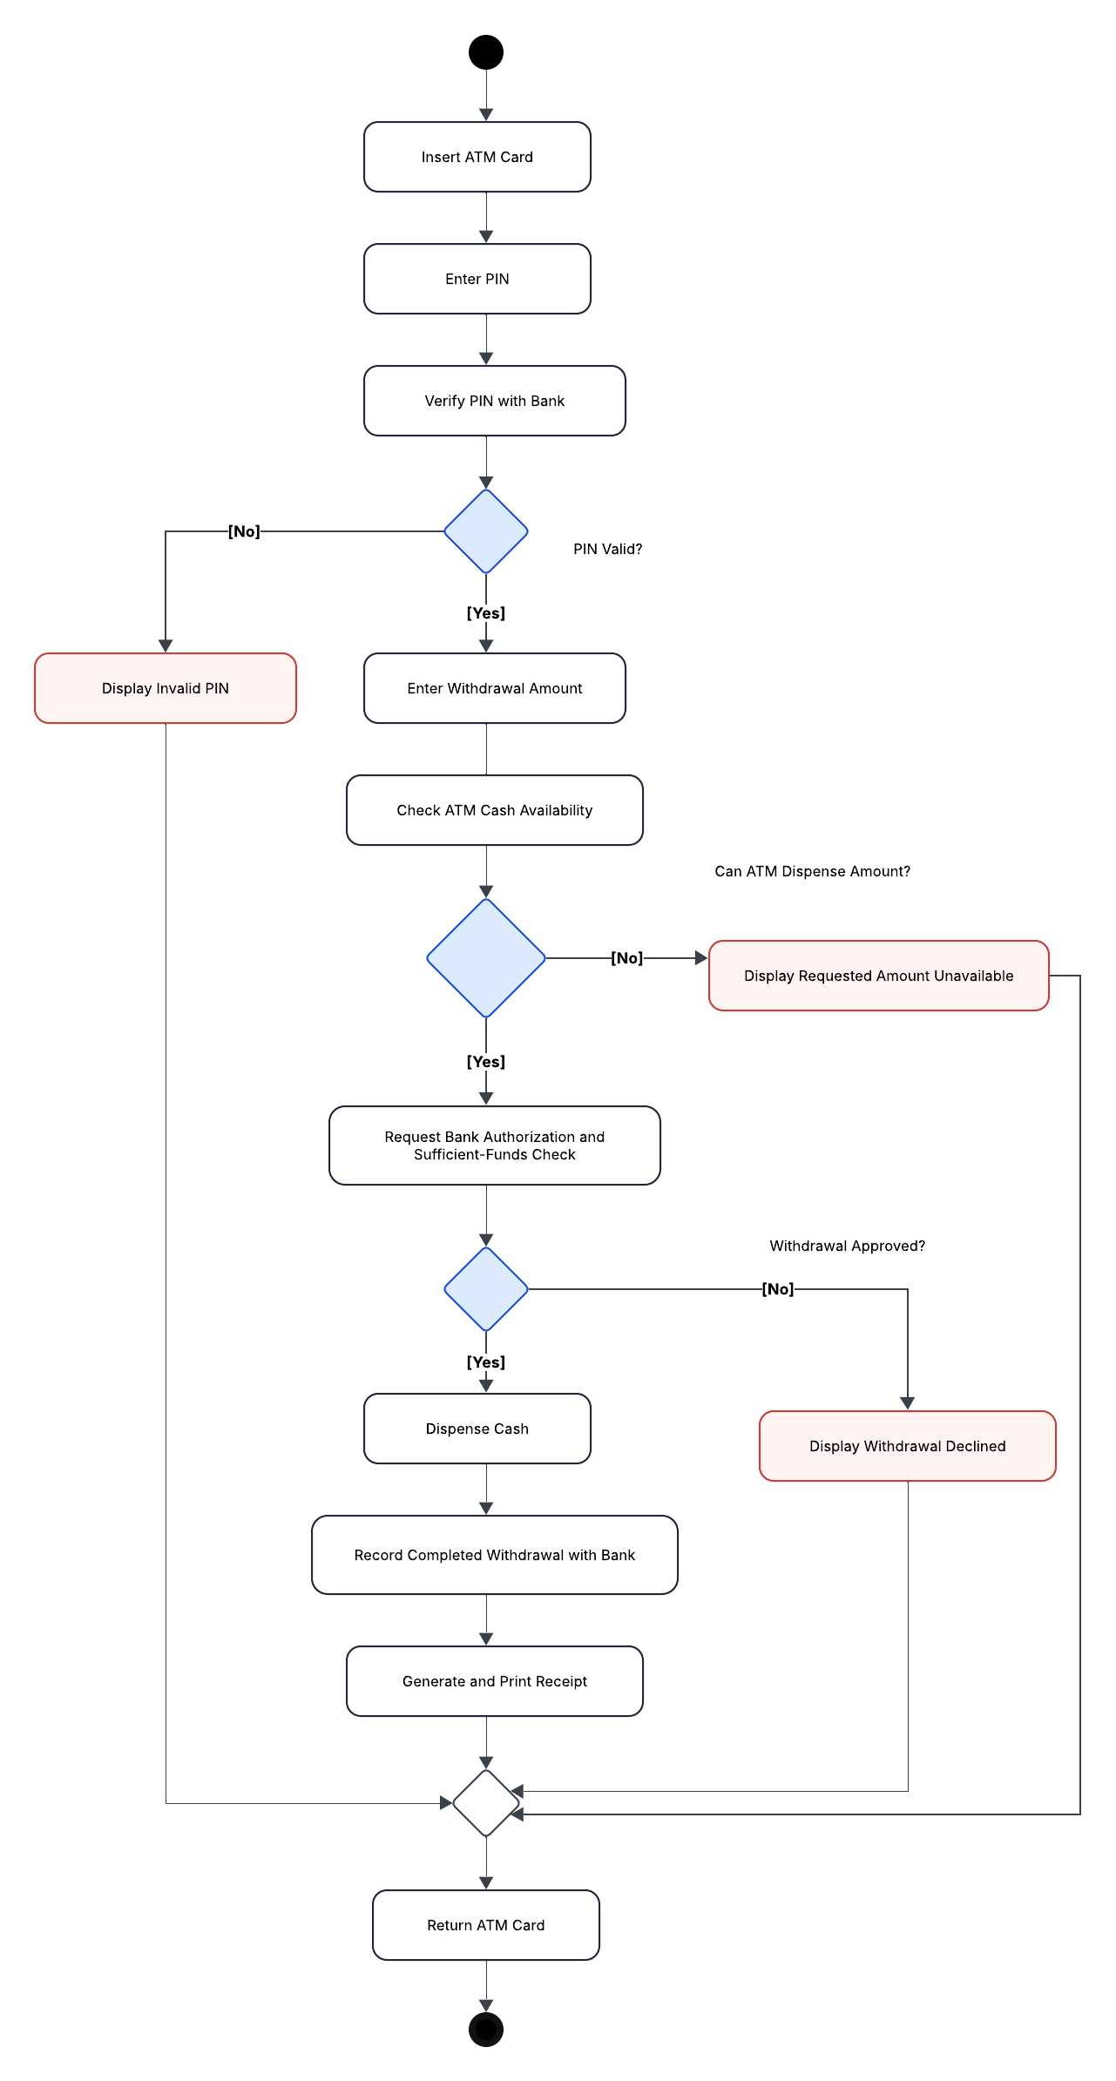
Figure 1: Revised UML Activity Diagram for ATM Cash Withdrawal.

